**Assignment No. 02**

**Semester: Fall 2021**

**CS205: Information Security**

**Solution:**

**Task- 1:**

Run the scanner of above mentioned tools and scan following websites:

* **<https://www.fbr.gov.pk/>**
* **<https://www.cam.ac.uk/>**

**QUALYS:**

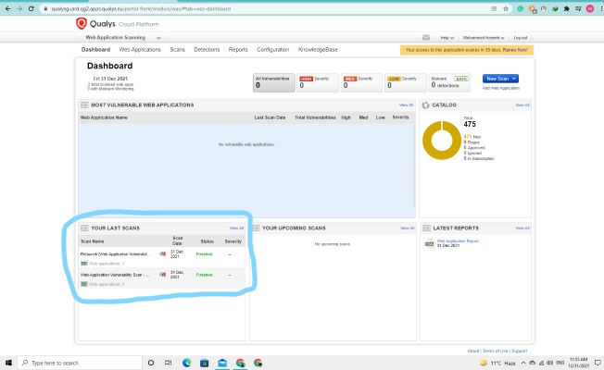

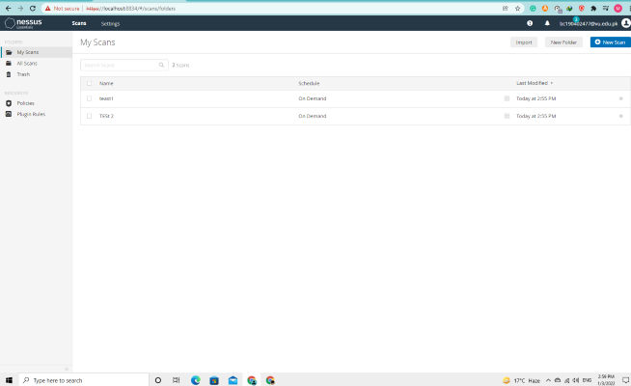

**Task- 2:**

After analyze your scanning results of both websites, select and enlist the name of more secure website.

* **<https://www.fbr.gov.pk/>**

**ANS:**

FBR is more secure website. Total 28 breaches were found ,in which 2 were sensitive because their severity is level 3.The website security is weak because Sub resource Integrity (SRI) Not Implemented and links Discovered During User-Agent and Mobile Site Checks.

* **<https://www.cam.ac.uk/>**

**ANS:**

This website security is weak, total 32 breaches were found in which 3 were sensitive issues because their severity is level 3 and the website security is also weak because Information Disclosure via Response Header and also Sub resource Integrity (SRI) Not Implemented, Links Discovered During User-Agent and Mobile Site Checks and rest of 5 breaches severity is level 2, and 24 severity level is 1.

**Task- 3:**

Scan Your Browser by using “Qualys Browser Check” feature.

* After scan, check the results and see what’s out-of-date and “Fix It” to update.
* If results are already up-to-date then no need to fix it.

